Cardamon [hel in Hebrew]: Picture of pods [fruit capsules] with 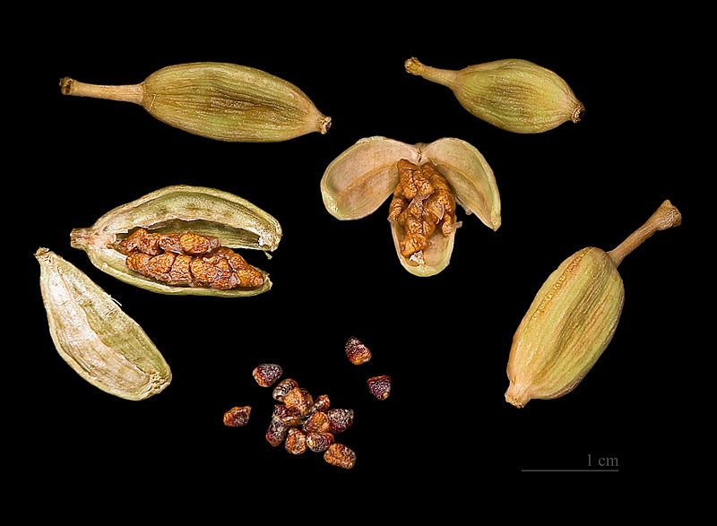seeds inside הל
Also: cardamom, Arabic: habbahan, hal, Turkish: hemame, hiyl, kakule, Italian: amomo
In the past cardamon has been one of the most expensive spices and it is still quite expensive. The pleasant aroma is caused by more than 25 volatile oils it contains and cineole is one of the most important one of these oils, also found in bay leaves.
Traditionally cardamon has been used for a wide variety of problems such gastro -intestinal problems[colic, sconstipation, diarrhoea] ,heart diseases and all kind of lung problems.
Digestion:
It has been shown to improve digestion,to calm the stomach -working cholinergic: means that it helps with increasing salivation {rok} improving digestion, smooth muscle relaxation [anticramp].
The above mentioned compound cineole helps against bad breath [especially after eating garlic] and may reduce the chances of stomach ulcers for chronic aspirin users. It may have a strong preventive effect against colon cancer.
When added to grains it enhances their digestibility and it also improves the digestibility of milk and dairy products.

Heart problems: -
lowering blood pressure, working like a diuretic.
Preventing blood clots [anti-thrombotic][heart attacks,strokes[cva]
Also reducing the heart frequency, meaning a slower pulse.
In Israel at least often used by the Arabs in coffee where it may help against palpitations [defikot lev] This is one of the parasymphatic effects.
Cardamon has been used as a stimulant for sexual arousal [erectile dysfunction], as an aphrodisiac in "love potions"][connected to better blood flow? Or because of the cineole which stimulates the nervous system?]

Respiratory system:
Relaxing the airways, can help to reduce the amount of people who are using steroids to control asthma.
Significant effect in acute sinusitis.

The best cardamon seems to come from southern India . It is widely used in the Indian kitchen [masala!] and also in the coking of the Arabic nations, Marocco and Iran.
As said above Arabs serve cardamon coffee [they may put a cardamon pod in the narrow [nose] of the coffeepot and then pour the coffee.
In Scandinavian countries cardamon is used to flavour cakes etc.

Some Western "scientific " herbal sites claim: There is insufficient reliable information available about the effectiveness of cardamom. Yes: there is also not enough reliable information about the Creation...........only the Torah claims so!! And thousand years of traditional use of cardamon .....and research that the best American sites have not seen or does not fit them.

What to buy?
Don't buy ground cardamon [it easily loses its flavours]
Buy the pods which should preferably not be split at the corners [loss of volatile oils]
Buy the smaller pods with a greenish to yellow-gray colour.
When needed, remove the outer covering of the pod [the fruit capsule], and grind the seeds if you wish.
Look for the smaller seeds, which are the best.
The seeds lose their flavour also more easily than the whole pods.
Intact cardamon seeds will keep for 2 years in an airtight container.
If a recipe asks for using bruised cardamon pods, then bruise the pod under a big knife [just like you crush garlic]? After cooking, remove the pods but but not the seeds.
If you want to use it in coffee [and don't want to use it in the traditional Arabic way then crush one pod and use that for 2 cups of coffee.
You can use cardamon of course in all kinds of other recipes [go to the Internet]
For example: use one or two bruised cardamon pods in the water of rice you are cooking.
Add a half teaspoon of freshly ground cardamon to gingerbrsead or chocolate cake.
Rub cardamon on lamb's meat before roasting.
Add cardamon to sweet fruit deserts.
Cardamon can also be bought as a "medicine" in the form of a tincture. One can use 3times a day a small teaspoon or less.
Maybe the easiest way to use cardamon as a medicine is to chew the seeds [ sore throat, cough, sinusitus, mental stress, asthma, gas, colic, lack of appetite ,lack of concentration etc]
The seeds can be chewed after chemotherapy against nausea or against travel sickness, with fennel seeds [don't forget also ginger in these cases]
In case of gall stones or hernia diaphragmatica don't use cardamon as a medicine [in large amounts] without consulting your doctor.
Cardamon may be combined also with cinnamon, ginger and caraway [kimmel] for problems of indigestion.
And what about trying cardamon on sufganiot?
This is not a chidush min Ha-Tora and allowed according to all opinions, I would think.......
Chanukka sameach!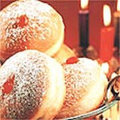

Sources :
Healing spices: Bharat Aggarwal
Brigitte Mars. The Desktop Guide to Herbal Medicine

